Analysis 1A — Tutorial 7

Christian Jones: University of Bath

November 2022

Table of Contents

# Introduction

Here is the material to accompany the 7th Analysis Tutorial on the 21th November. As usual, send comments and corrections to [Christian Jones (caj50)](mailto:caj50@bath.ac.uk)

# Lecture Recap

## Limit Superior and Limit Inferior

It is not always the case that the limit of a sequence exists — take ${\left(a_{n}\right)}_{n∈N}$ defined by $a_{n}={\left(−1\right)}^{n}$, for example. But if a sequence ${\left(a_{n}\right)}_{n∈N}$ is bounded, there are two objects that always exist. These are the *limit superior* and *limit inferior* of a sequence. To start define these, we first let $\left(a_{n}\right)$ be a real sequence, and for each $k∈N$, define

$$A_{k}=\{a_{n} | n≥k\}=\{a_{k}, a_{k+1} …\}$$

We also use some different notation to describe the supremum and infimum of the sets $A_{k}$, namely [1]

One thing we can say about these quantities is that since $A_{k+1}⊆A_{k}$, we know that ${\left(\text{sup}A_{k}\right)}_{k∈N}$ is a decreasing sequence, and ${\left(\text{inf}A_{k}\right)}_{k∈N}$ is an increasing sequence. Now that we’ve produced two new sequences, the natural thing to do is analyse their convergence. It turns out that if ${\left(a_{n}\right)}_{n∈N}$ is bounded, both ${\left(\text{sup}A_{k}\right)}_{k∈N}$ and ${\left(\text{inf}A_{k}\right)}_{k∈N}$ converge! We define their respective limits to be [2]

The first of these is the *limit superior* and the second is the *limit inferior*. These can be thought of as `eventual’ bounds on a sequence, as seen in Figure 1.1 (Taken from [Wikipedia](https://en.wikipedia.org/wiki/Limit_inferior_and_limit_superior)).

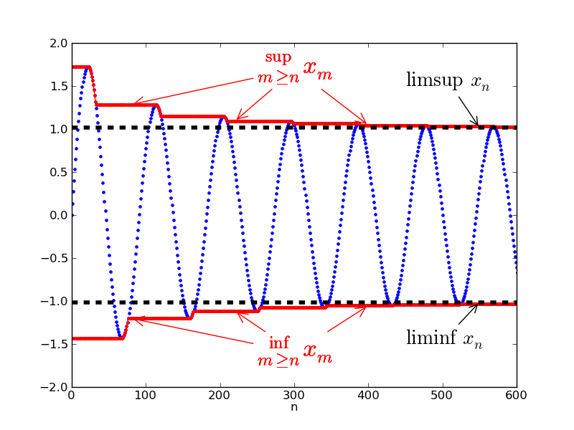

Figure 1.1: Limsup and liminf for a sequence.

There is also another way of interpreting the limits superior and inferior. For a sequence ${\left(a_{n}\right)}_{n∈N}$, we can also think of ${\text{limsup}}_{n→∞}a_{n}$ and ${\text{liminf}}_{n→∞}a_{n}$ as being the largest and smallest possible limits of any subsequence of ${\left(a_{n}\right)}_{n∈N}$. We can use this to characterise convergent sequences!

Theorem 1.1

A sequence ${\left(a_{n}\right)}_{n∈N}$ is convergent if and only if

$$\underset{n→∞}{\text{limsup}}a_{n}=\underset{n→∞}{\text{liminf}}a_{n}.$$

To end this section, we state two more results. They’re not mentioned in the lecture notes, but they can be incredibly useful when performing calculations[3].

Theorem 1.2

Let ${\left(a_{n}\right)}_{n∈N}$ and ${\left(b_{n}\right)}_{n∈N}$ be real sequences. Then:

$$\underset{n→∞}{\text{limsup}}\left(a_{n}+b_{n}\right)≤\underset{n→∞}{\text{limsup}}a_{n}+\underset{n→∞}{\text{limsup}}b_{n},$$

and

$$\underset{n→∞}{\text{liminf}}\left(a_{n}+b_{n}\right)≥\underset{n→∞}{\text{liminf}}a_{n}+\underset{n→∞}{\text{liminf}}b_{n}.$$

## Series

It might look like we’re done with sequences, but in the grand scheme of things, we’re only really getting started. Since with each sequence ${\left(a_{n}\right)}_{n∈N}$, we have an infinite list of real numbers, we might consider trying to manipulate them in some way. One way we can do this is by adding them together, which leads to the notion of a *series*.

Definition 1.1 (Series)

Let ${\left(a_{n}\right)}_{n∈N}$ be a real sequence. Then

$$\sum_{n=1}^{∞}{a_{n}}$$

is called a series for ${\left(a_{n}\right)}_{n∈N}$.

Much like with sequences, we have an analogous version of convergence for a series:

Definition 1.2 (Series Convergence and Partial Sums)

Let ${\left(a_{n}\right)}_{n∈N}$ be a real sequence. Then $\sum_{n=1}^{∞}{a_{n}}$ converges if and only if the sequence ${\left(S_{N}\right)}_{N∈N}$ converges, where

$$S_{N}:=\sum_{n=1}^{N}{a_{n}}$$

is the $N$ partial sum. If $S_{N}→ℓ$ as $N→∞$, we define

$$ℓ=\sum_{n=1}^{∞}{a_{n}}.$$

If ${\left(S_{N}\right)}_{N∈N}$ diverges to $±∞$, we say that the corresponding series

$$\sum_{n=1}^{∞}{a_{n}}=±∞.$$

Finally, if ${\left(S_{N}\right)}_{N∈N}$ doesn’t converge to a limit, we say that the series diverges without limit.

### Algebra of Series

By applying the algebra of limits to the sequences of partial sums, we can deduce some handy results.

Theorem 1.3 (Algebra of Series)

Let $\sum_{n=1}^{∞}{a_{n}}$ and $\sum_{n=1}^{∞}{b_{n}}$ be convergent series, and let $α,β∈R$. Then

$$\sum_{n=1}^{∞}{\left(αa_{n}+βb_{n}\right)}=α\sum_{n=1}^{∞}{a_{n}}+β\sum_{n=1}^{∞}{b_{n}}.$$

### Some Other Useful Results

Firstly, we can relate the size of the terms of a series to the overall sum.

Proposition 1.1

Let $\sum_{n=1}^{∞}{a_{n}}$ and $\sum_{n=1}^{∞}{b_{n}}$ be real series. If $a_{n}≤b_{n} ∀n∈N$, then

$$\sum_{n=1}^{∞}{a_{n}}≤\sum_{n=1}^{∞}{b_{n}}.$$

Secondly, we have a *necessary* condition for convergence of a series.

Proposition 1.2

Let $\sum_{n=1}^{∞}{a_{n}}$ be a convergent series. Then $a_{n}→0$ as $n→∞$.

Note that the converse of this theorem *does not* hold (think of the sum $\sum_{n=1}^{∞}{\frac{1}{n}}$). However, the contrapositive is very good at showing that a series does not converge!

Proposition 1.3

Let $\sum_{n=1}^{∞}{a_{n}}$ be a series. If $a_{n}↛0$ as $n→∞$, then $\sum_{n=1}^{∞}{a_{n}}$ does not converge.

# Hints

As per usual, here’s where you’ll find the problem sheet hints!

* [H1.] Try using a similar argument to the one used in tutorial question 1 (i.e. use the fact that the sequence can be split into odd and even cases to your advantage)
* [H2.] For this question, think about what it means for a series to be convergent. You’ll also want to split the terms of the series up in some way. (Think of tutorial question 3a.)
* [H3.] For the first part, think induction. The only other thing I’ll say is to make sure you state all the main results you use!

1. The notation here follows that used in the lecture notes rather than that used in lectures, as this is more common usage. Also, for convenience, if the set $A_{k}$ is not bounded above/below, we set the supremum/infimum to be /.
2. Again, if ${\left(\text{sup}A_{k}\right)}_{k∈N}$ diverges to $∞$, ${\text{limsup}}_{n→∞}a_{n}$ is defined to be $∞$, and if ${\left(\text{inf}A_{k}\right)}_{k∈N}$ diverges to $−∞$, ${\text{liminf}}_{n→∞}a_{n}$ is defined to be .
3. Since these results are not in the lecture notes, it’s *highly* recommended that you try and prove them yourself. Try using similar techniques to Tutorial Question 2 on Problem Sheet 7 and Homework Question 2 on Problem Sheet 3.